Instructions for purchasing a parking permit online

Before you purchase a permit, you will need to have your vehicle license plate information, permit mailing address and credit card information available.

- Visit our website at parking.vcu.edu

- Click on “Manage My Account” in the upper right-hand corner of the site.

- Click “LOGIN” in the upper right-hand corner, then click on the “VCU/VCUHS Login” button. Note: If you are purchasing a temporary permit, you can create a guest account by clicking “SIGNUP” instead of “LOGIN.” Permanent/long-term subscriptions will require your eID and password.
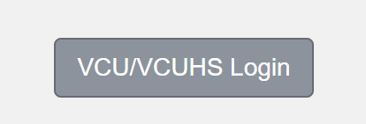

- Use your VCU eID and password to log in to the site. If you do not know your eID, click “Don’t know your eID?” Provide your birthday and VCU ID card information to retrieve your eID.
- Not sure of your password? You may need to reset it or activate your eID. Click on “Forgot your password?” Enter your eID and follow the prompts. Once completed, hit “Login.”

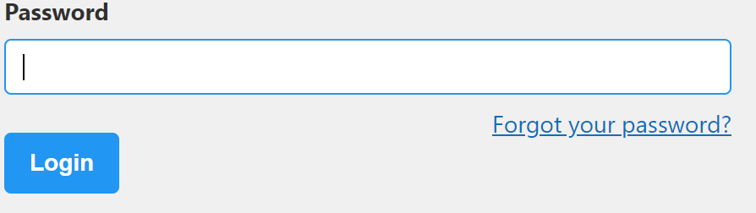

- Once you log in successfully, click on “PERMITS” at the top of the site, then click on “GET PERMITS.”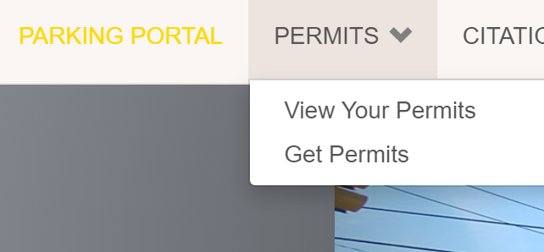

- Click on “Next >>” at the bottom of the screen to purchase a permit.
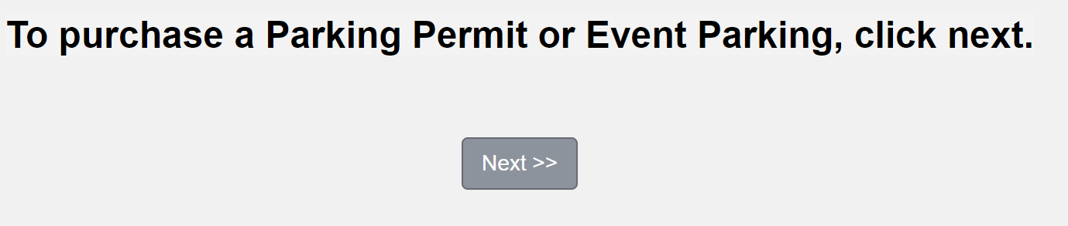
- Select your permit and review the permit agreement.

- After reviewing and agreeing to abide by the permit agreement and parking guidelines, check the boxes to proceed.

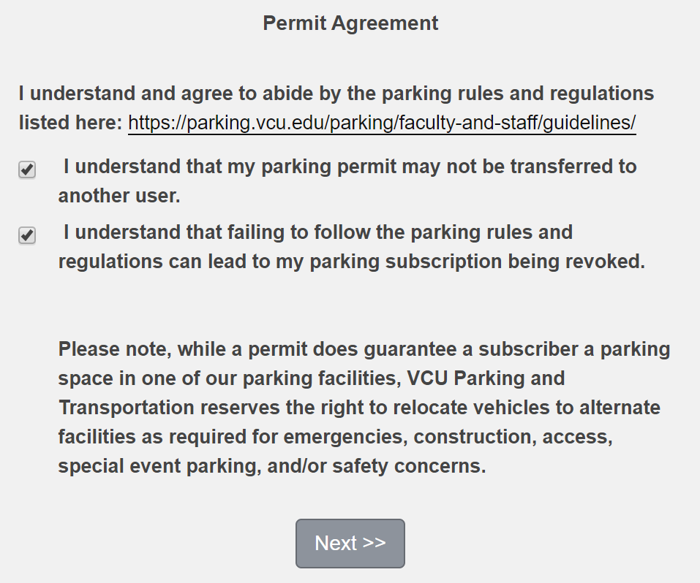

- Confirm your dates (if temporary), vehicle information, and mailing address. If you are purchasing a temporary permit, select “print at home.” 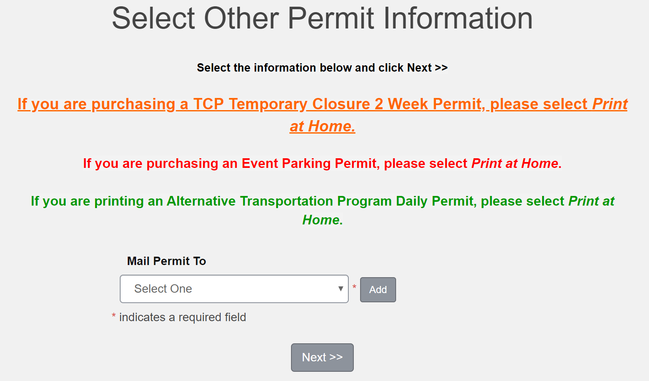

- Review your purchase, and hit “Pay Now” to complete check out. You can pay with any major credit card. If you are a full-time employee, you can select payroll deduction as your payment method if A Lot at Main St. Station is your parking selection.

- Click on “Next,” then enter your credit card information.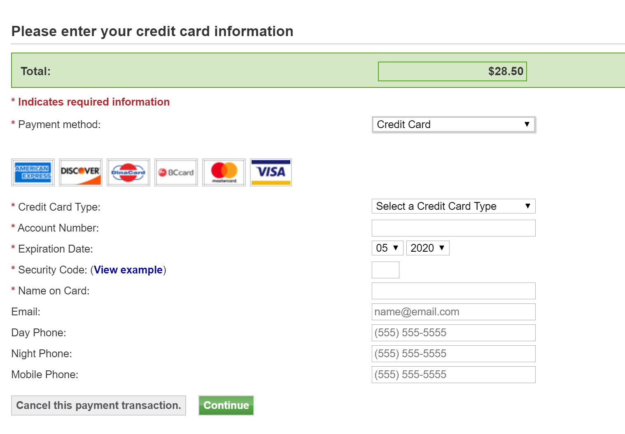

- Be sure not to hit the back or refresh buttons on your browser while your payment is processing.

- You will receive a confirmation when your purchase is complete.

- Print and display your temporary permit on your dashboard. If you are using a temporary permit for the Eighth St. Deck, scan the barcode or your VCU ID card at the gate entrance to enter and exit the facility. If you are parking in A Lot at Main St. Station, your hangtag permit will arrive in the mail within five to ten business days.

- You’re all complete! If you have any questions, contact parking@vcu.edu.

